**REST - Country Web Service** 

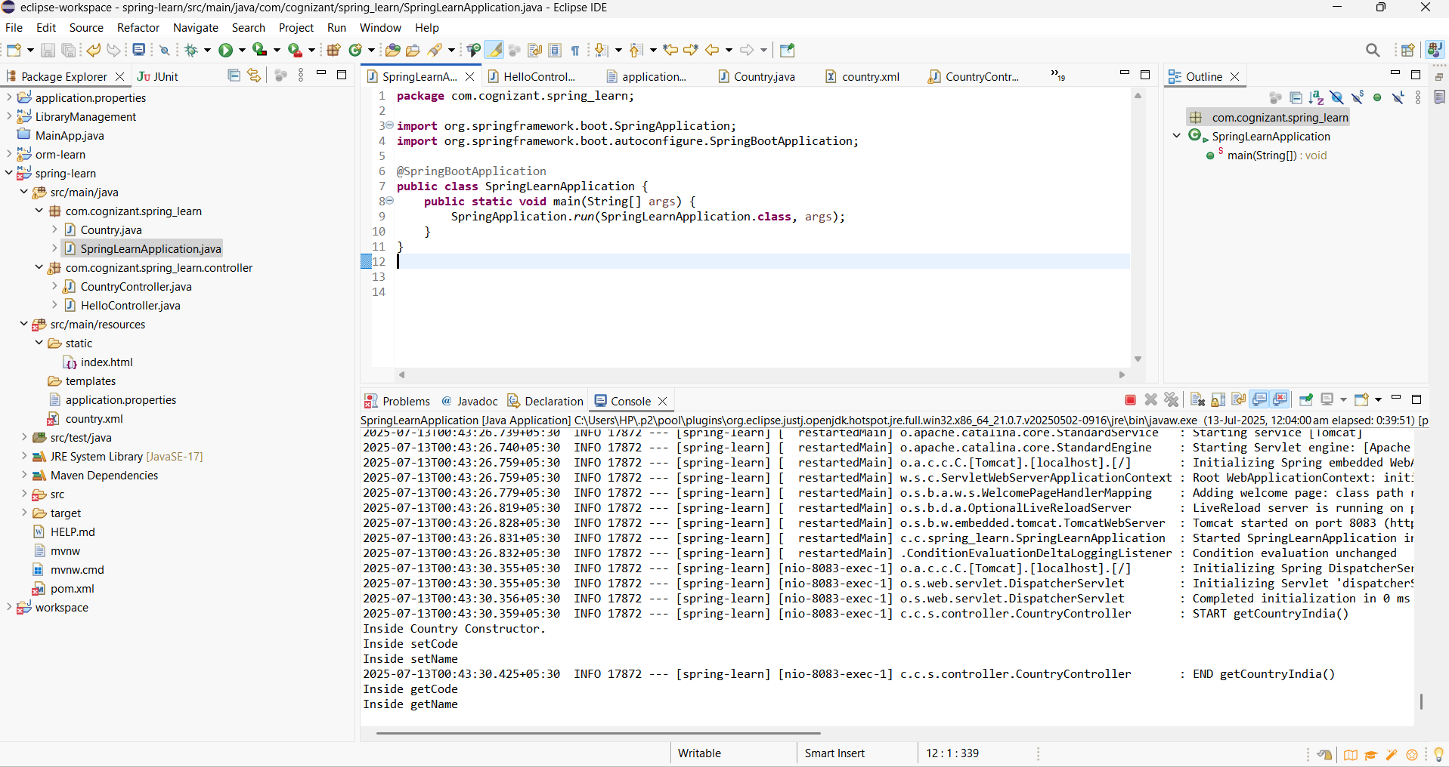

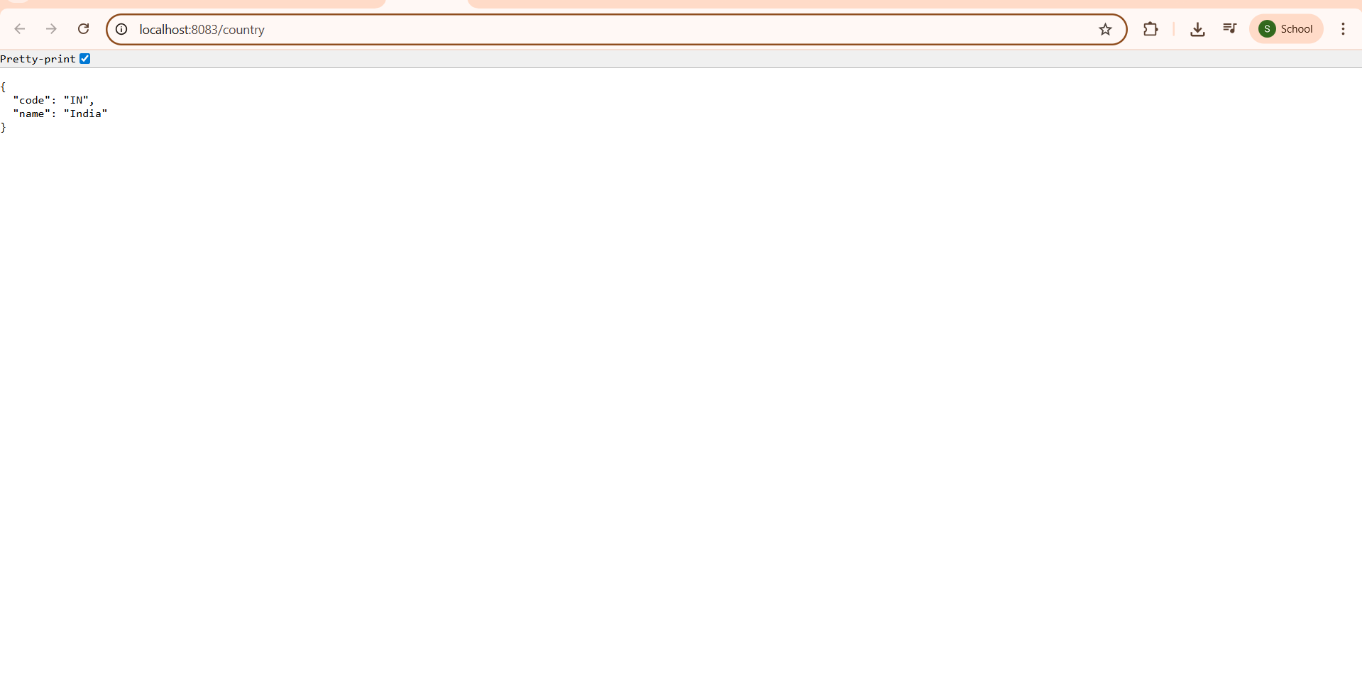

### ✔ What happens in the controller method?

When the endpoint /country is hit:

The controller method is invoked.

It loads the Spring context from country.xml.

It fetches the bean with ID country (which is pre-configured with India’s details).

It returns the bean.

### ✔ How is the bean converted to JSON?

Spring Boot uses **Jackson** (automatically included) to convert Java objects into JSON.

The @RestController and @RequestMapping combination triggers this auto-conversion.

The returned Country object is converted by the **HttpMessageConverter** (Jackson behind the scenes).

